Lab 9 - STAT 123

Eric Huber

30/03/2022

## Question 1:

# a  
df = read.csv("media_spend.csv")  
  
#b,c  
par(mfrow = c(1,3))  
  
cnames= c("TV Ad", "Radio Ad", "Newspaper Ad")  
colours = c("dodgerblue", "firebrick1", "green3")  
  
  
for(i in 1:3){  
 ttl = paste("Sales vs", cnames[i])  
 plot(df[,i], df[,4], main = ttl, ylab = "# of Sales", col = colours[i], xlab = cnames[i])  
   
 i = i+1  
   
}

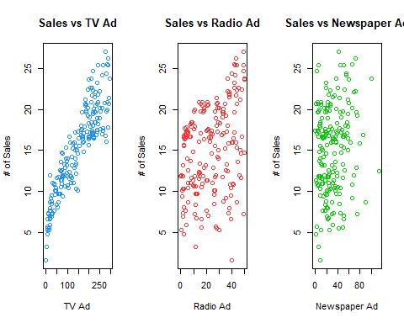 ### (1.c) Looking at our plots it appears that TV ads seem to be the most positively correlated having the largest affect on sales!

## Question 2:

res = numeric(3)  
  
names(res)= c("TV", "Radio", "News")  
  
  
fit_TV = lm(formula =df$Sales~df$TV)  
  
res[1] = summary(fit_TV)$coefficients[2, 4]  
  
res[2] = summary(lm(Sales ~ Radio, data = df))$coefficients[2,4]  
  
res[3] = summary(lm(Sales ~ Newspaper, data = df))$coefficients[2,4]  
  
res

## TV Radio News   
## 7.927912e-74 3.882892e-07 2.548744e-02

Based on our results it’s clear to see that TV is by far the most significant regressor as it has the smallest p value.